## Employee Database

1. Using Scheme diagram, Create tables by properly specifying the primary keys and the foreign keys.
2. Enter greater than five tuples for each table.
3. Retrieve the employee numbers of all employees who work on project located in Bengaluru, Hyderabad, or Mysuru
4. Get Employee ID’s of those employees who didn’t receive incentives
5. Write a SQL query to find the employees name, number, dept, job_role, department location and project location who are working for a project location same as his/her department location.

### Schema Diagram

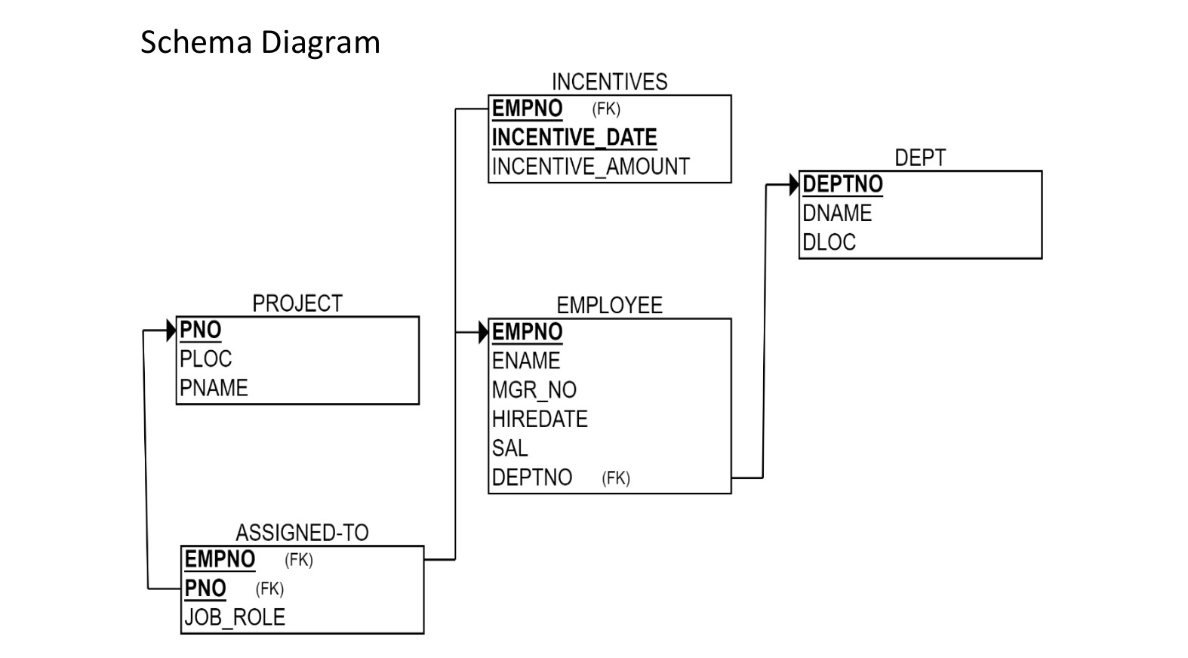

### Create database

### create database employee_1BM23CS081;

### use employee_1BM23CS081;

### Create table

### create table DEPT_081(

### dept_no int ,

### dname varchar(30),

### dloc varchar(55),

### primary key(dept_no));

### create table PROJECT_081(

### pno int ,

### ploc varchar(30),

### pname varchar(55),

### primary key(pno));

### create table EMPLOYEE_081(

### empno int ,

### ename varchar(55),

### mgr_no int,

### hiredate date,

### sal int,

### dept_no int ,

### primary key(empno),

### foreign key(dept_no) references DEPT_081(dept_no));

### create table INCENTIVES_081(

### empno int ,

### incentive_date date,

### incentive_amount int,

### primary key(empno , incentive_date ),

### foreign key(empno) references EMPLOYEE_081(empno));

### create table ASSIGNED_081(

### empno int,

### pno int,

### job_role varchar(55),

### primary key(empno, pno),

### foreign key(empno) references EMPLOYEE_081(empno),

### foreign key(pno) references PROJECT_081(pno));

### Structure of the table

DEPT_081

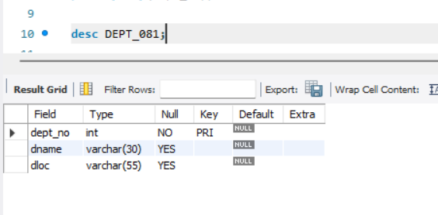

PROJECT_081

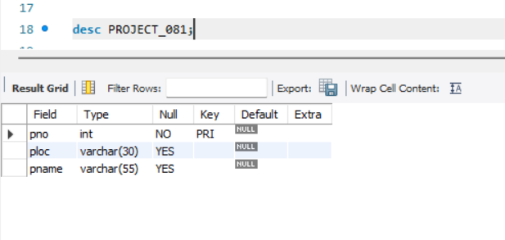

EMPLOYEE_081

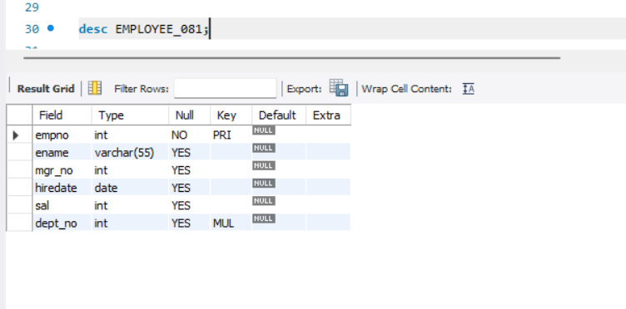

INCENTIVES_081

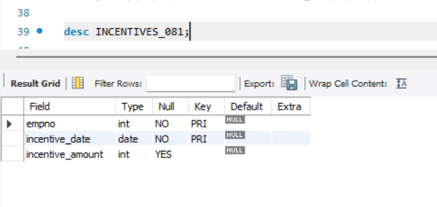

ASSIGNED_081

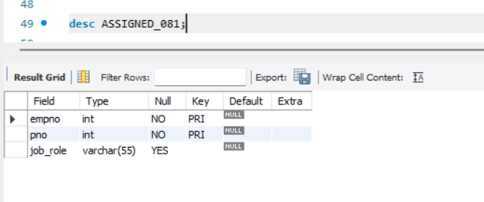

### Inserting Values to the table

insert into DEPT_081(dept_no, dname, dloc)

values (1, "IT", "MUMBAI"),

(2, "AI", "BANGALORE"),

(3, "DATA SCIENCE", "DELHI"),

(4, "ML", "HYDERABAD"),

(5, "ADMINISTRATION", "MYSORE"),

(6, "LEGAL", "MANGALORE");

insert into PROJECT_081(pno, ploc, pname)

values (1, "BANGALORE", "WEB DEV"),

(2, "MYSORE", "APP DEV"),

(3, "DELHI", "NLP"),

(4, "MUMBAI", "AR GAME"),

(5, "HYDERABAD", "IOT AUTOMATION"),

(6, "BANGALORE", "AI CHATBOT"),

(7, "MUMBAI", "CRYPTO CURRENCY"),

(8, "MYSORE", "TRAFFIC MANAGEMENT");

insert into EMPLOYEE_081(empno, ename, mgr_no, hiredate, sal, dept_no)

values (1, "ABAY", 5, '2024-01-15', 48000, 4),

(2, "JOHN", 1, '2023-03-22', 50000, 1),

(3, "DANIEL", 2, '2022-06-10', 82000, 5),

(4, "DAVID", 8, '2023-09-30', 95000, 6),

(5, "JAMES", 1, '2020-12-05', 55000, 2),

(6, "THOMAS", 5, '2017-11-01', 65000, 1),

(7, "ROBERT", 8, '2019-04-18', 75000, 5),

(8, "LAURA", 2, '2018-08-25', 80000, 3);

insert into INCENTIVES_081(empno, incentive_date, incentive_amount)

values (4, '2024-05-20', 1800),

(3, '2024-06-30', 2500),

(8,'2024-09-18', 1700),

(7, '2024-03-15', 2200),

(1, '2024-02-01', 1950);

insert into ASSIGNED_081(empno, pno, job_role)

values (6, 8, "MANAGER"),

(1, 3, "AI RESEACHER"),

(3, 2, "APP DEVELOPER"),

(5, 5, "DEVOPS ENGINEER"),

(2, 4, "GAME DEVELOPER"),

(7, 1, "WEB DEVELOPER"),

(4, 7, "ANALYST"),

(8, 6, "AIML ENGINEER");

**Inserted Values**

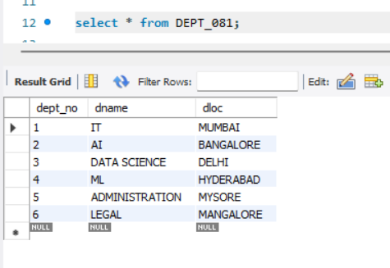

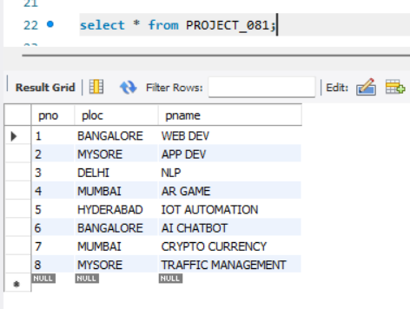

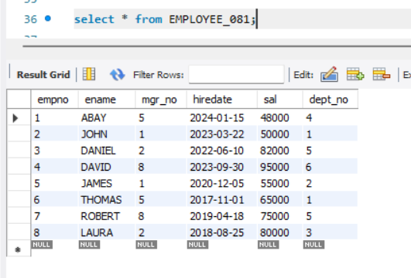

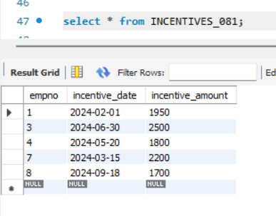

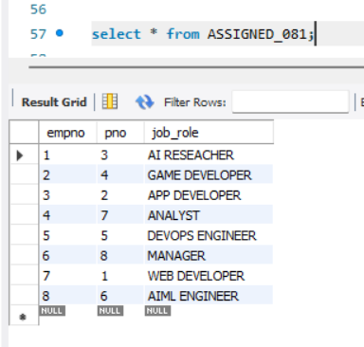

**Queries**

**1.Retrieve the employee numbers of all employees who work on project located in Bengaluru, Hyderabad, or Mysuru.**

**Query :** select ASSIGNED_081.empno from ASSIGNED_081, PROJECT_081 where ASSIGNED_081.pno = PROJECT_081.pno and PROJECT_081.ploc in ("Bengaluru", "Mysuru", "Hyderabad");

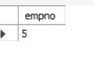

**2.Get Employee ID’s of those employees who didn’t receive incentives** Query : select empno from employee_204 where empno not in (select empno from incentives_204);

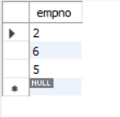

**3.Write a SQL query to find the employees name, number, dept, job_role, department location and project location who are working for a project location same as his/her department location.**

Query : select e.ename, e.empno, d.dept_no, a.job_role, d.dloc, p.ploc

from EMPLOYEE_081 e, DEPT_081 d, ASSIGNED_081 a, PROJECT_081 p

where e.dept_no=d.dept_no and a.empno=e.empno and a.pno=p.pno and p.ploc=d.dloc;

